**BISHOPSTONE PARISH**

**ANNUAL PARISH MEETING**

**Held in Bishopstone Village Hall**

**Thursday 14th March 2024 at 7.00 pm.**

**MINUTES**

**Present :** Cllr A J Thorne Mrs W Prior

Cllr P Edwards Mrs A Cotton

Cllr N Barter Mrs P Abbott

Cllr Mrs M Tatner Mr R Abbott

Cllr S Williams Mr R Stockton

Cllr Ms N Rigg Mr F Taylor

Mr M Ash Mrs C Ash

Wiltshire Cllr Nabil Najjar

Mr M Pratt

Mrs S Seal

1. **Election of Chairman**: Cllr Thorne took the Chair,
2. **Apologies for absence:** Apologies had been received from Cllr A Smith.
3. **Minutes of the last meeting:** R Stockton proposed that the minutes of the Annual Parish Meeting held on 9th March 2023 be approved as an accurate record. This was seconded by Mrs W Prior and agreed.
4. **Reports.**

Reports were presented by Cllr Nabil Najjar (Wiltshire Council), Cllr Ali Thorne (Parish Council), Mrs S Seal (Parochial Church Council), Cllr Norman Barter (Village Hall Management Committee), Cllr P Edwards (Emergency Planning) and by Mr M Pratt (Tree Warden).

**Cllr Najjar** thanked the Parish Council for everything it does; all of which makes his job easier. He said that Wiltshire Council had agreed its budget for next year and difficult decisions had been taken regarding some services. The Council was determined to avoid the problems that other authorities were encountering and not to delve into its reserves. A new initiative had been announced to provide more support for farmers, particularly as they try to diversify their revenue streams. He was aware that Bishopstone, along with Broad Chalke Council, was awaiting the result of speed assessment studies in relation to proposed changes to speed limits along two short sections of the C12. These had been delayed because a decision had been taken to consider the whole length of the C12 as regards the volume of traffic, the standard of the road and speed limits. A report has now been prepared and recommendations for change should be available soon.

A question was raised as regards the standard of repair work undertaken to potholes and other road works, which tend not to last. It was also pointed out that the growing problem was the state of the road margins where bigger vehicles had created deep gutters. These were potentially dangerous and the wheels of smaller cars were being damaged. Councillor Najjar agreed that the budget for highway repairs, £10 million, was probably not adequate, but the scope for adding to that budget was limited. Sixty five percent of Wiltshire’s budget went on adult and child social care (a level of expenditure mandated by central government) which left relatively little for everything else. However, the South West Area Board proposed to conduct a survey to identify priority roadworks and the Parish Council should send him their list for consideration.

Copies of the reports from **Cllr Thorne, Mrs Sarah Seal and Cllr Barter** are attached to these minutes.

**Cllr Edwards** said that, despite the very wet autumn and winter, flooding in the village had not been widespread. Thanks to the work of Wiltshire Council the position in Faulston Lane was much improved, though problems remained in Netton Street. The emergency stores were well stocked and pumps had been checked. He reminded property owners of their responsibility to keep their own property secure.

**Michael Pratt** gave a presentation on the types of activity that he hoped to promote as Tree Warden. The intention of this initiative by Wiltshire Council is to significantly increase tree cover in the county to help combat climate change. The aim is to recruit Tree Wardens in every parish, with events for training and sharing ideas. A range of organisations are now providing grant support for tree planting. Tree Wardens can undertake surveys of tree cover in their area, identify places to plant new trees, make grant funding applications and provide training to others. However, it is important to recognise the limits of this initiative and the things that Tree Wardens should not do – such as give advice to tree owners that creates a liability or undertake work without a proper risk assessment. Consideration could be given to such projects as whether to plant a community orchard in the margins of the Recreation Field and creating a tree nursery to supply saplings for planting in gardens and farms in the village. He is to be joined as a Tree Warden by Georgie Phillips who will look after the western end of the village. Further information about this project will be announced in STaB in due course. Copies of slides on this initiative are attached to these minutes.

1. **Open Forum**:

Concerns were raised about the deposit of material dredged from the drainage channel in Church Lane along the wall of the churchyard and about the effect of road closures along the C12. It was agreed that the Parish Council should write again to Wiltshire Council highways pointing out that the dumping of material from the drain in Church Lane is unacceptable. If this continued it would raise the height of the bank and, in due course, obliterate the wall which is part of a Grade I Listed Building. The deposit of wet silt against the wall risked damage and destruction of its setting, contrary to Wiltshire’s own conservation policies. It was understood that the problem was the logistics of offsite disposal, but Cllr Thorne said that he would be able to help with this.

1. The problems caused by road closures had been raised with Wiltshire Council on numerous occasions. Their position was that there was little they could do to stop “rat running” along Mill and Faulston lanes and that the minimum width requirements for keeping the road open with traffic light control could not be met. However, some progress had been made in getting them to insist that statutory undertakes minimise the number of road closures required.
2. **Date of Next Meeting**

It was agreed that for 2025 the date of the Annual Parish Meeting should be moved to May in the hope that the lighter evenings would encourage greater attendance. The next **Annual Parish Meeting** will therefore be held on the 8th May 2025 at 7.00pm in the Village Hall.

Signed as an accurate record.

…………………………………….Chairman …………………………….Date

**BISHOPSTONE ANNUAL PARISH MEETING – THURSDAY 14TH MARCH 2024**

**REPORTS BY VILLAGE ORGANISATIONS**

1. **Cllr Ali Thorne - Bishopstone Parish Council**

The Parish Council has undertaken a number of projects in the past year. A new seat was installed in the Children’s Play Area to commemorate the Coronation of King Charles III. We will be hearing later about the additional defibrillator that has been provided to cover the eastern end of the village. The Council was able to assist the Parochial Church Council with meeting the costs of work to clear vegetation and reinstate graves in the church yard. We also met 50% of the costs of resurfacing part of Pitts Lane where it meets the High Road and organised work to help repair and maintain footpaths in the village.

Some progress has also been made in the quest to secure a reduced speed limit on Broadchalke Road where it passes the Recreation Field and the White Hart. This has been a long standing objective, with previous requests for a reduction from 40mph to 30mph rejected by Wiltshire Council. Following signs that Wiltshire are now more prepared to listen to resident’s concerns about speeding, a further application was made. A speed limit assessment has been undertaken by consultants appointed by Wiltshire and we await the results. If this bid is successful the Parish Council will need to meet 25% of the legal and signage costs.

Whilst on the subject of roads, one of the major concerns this year has been the spate of road closures, mainly for work by Openreach, but also Wiltshire Council highways. It is not apparent whether Wiltshire Council, who make the road closure orders, really appreciate the extent of the problem these closures create. The bus service is suspended, causing real difficulty for more elderly residents, children have problems getting to school and businesses located in the village have their operations disrupted.

When the High Road is closed the formal diversion route is some 17 miles via Wilton and Fovant. It is not surprising that many drivers choose instead to “rat-run” round Mill and Faulston Lanes causing traffic chaos and environmental damage. The Parish Council has had lengthy discussions with Wiltshire Council about the need to completely close roads (health and safety!) and on measures to prevent the use of unsuitable diversion routes. Unfortunately it would seem there is little that Wiltshire can do. Although they have undertaken to talk to utility companies about the need to minimise closures and, in particular, not to cancel work at the last minute once closures have been announced. Let us hope that most of the necessary infrastructure work has now been completed.

We have had a wet Autumn and Winter and, inevitably, there has been some flooding. The good news is that, again after many years of pressure from the Parish Council, Wiltshire undertook quite major work to deal with drainage problems in Faulston Lane. As a result there was no serious flooding there. The same is not true of Netton Street, where everybody, including Wiltshire Council, recognises that the existing drains cannot cope with the downpours we now experience, but where the major reconstruction that would be necessary is unlikely to be a priority for the County. We will continue to press for action here.

Finally I want to mention those in the village that act in support of the Parish Council. These include, in particular, Michael Pratt and Nigel Peasley our Flood Wardens - as you will hear later Michael Pratt has also taken on the role of Tree Warden. He, and John and Henry Thorne, have also turned out to clear trees that have come down across roads in the village in stormy weather – keeping roads open when they would otherwise have remained closed for extended periods waiting for Wiltshire Highways to attend. They all deserve our thanks.

1. **Mrs Sarah Seal – Parochial Church Council**

Without the same threat from Covid, the Church was finally able to hold its usual quota of services. We welcomed a lot of people again to services such as Harvest, and the Remembrance service. This year we held the carol service in the Village Hall again, which allowed many more people to attend. But we were also able to welcome nearly 90 people to our service of Carols round the Crib on Christmas eve. In the Summer we were able to resume holding a choral Evensong in Stratford Tony Church, and at Christmas we held our first carol service there, with the congregation being ferried back and forth by cars capable of getting through the flood water.

Thanks to the Friends, a lot of work has been done in the church. Repairs have been made to the stonework around one of the windows in the north transept, on parts of the east chancel wall, and the cloister roof. Inside, a start was made to wash down and remove four layers of distemper on the nave walls, which will be repainted this year. New hand rails were also installed at the entrance to the porch, a gift from Hester Kirkham.

But two things happened last year, which placed an extra financial burden on the church. A large branch from the beech tree, fell onto the newly thatched wall on the opposite side of the road, causing damage. We felt we had to get the tree surveyed, as if it were to come down in a storm or lose another large branch, it would not only be a danger to people passing by, but it could bring down power and telephone cables which run through it. It could also do serious damage to the church and gravestones. As a result, the tree canopy was reduced, and dead branches removed. The cost of which was over £1500.

We also enrolled in a scheme to have the churchyard surveyed. The survey itself is free. It will record where all the burials are located, and all the memorials and church records will be scanned. It will provide an accurate plan of the churchyard, and form a record that the public can access. BUT anything hidden cannot be mapped or photographed. Over the years, many graves have been engulfed by hedges or brambles and ivy. With the help of volunteers, we are clearing away all this debris. But it has left a large area which needs to be levelled using a digger, and has revealed an old stone gateway which needs to be repaired. Another additional expense.

We therefore approached the Parish council to see if they could help us, and they came to our rescue with a generous additional grant. They also increased the grant for mowing the grass, as there is now a greater area to be kept under control.

Mike Ash asked me to explain why we needed to ask the Parish council for financial help.

Our finances at first glance looks very healthy. But, the majority of our money, is either restricted, or designated for specific purposes. It includes funds raised by the friends, which can only be used for the upkeep of the fabric of the church. Just over £17,000, has been donated specifically for the restoration of the organ, which will start in April. It includes the interest from the Montgomery Fund, used to help people in financial need in our village. A generous donation given by a local benefactor has been designated for the upkeep of Stratford Tony Churchyard.

Our only sources of income, are from people who give a regular amount to the church, church collections at services, and a portion of the fees from weddings, funerals, and christenings, or memorials installed in the churchyard. Part of these fees, have to be paid to the diocese. The Parish council also gives us help to maintain the churchyard.

Our expenses are high, for example the Parish share which is paid to the diocese, is currently £15,413. It is going to rise, possibly by as much as 8%. Fees and our share of the cost of running our Benefice was over £4500. Insurance was over £4000, general maintenance was around £3000. Last year despite extra help from the Parish Council, our expenses exceeded our income by £1,309.

I should just say that if it were not for the generosity of people who provide such things as the flowers for the church, coffee and biscuits after services, the mulled wine etc after the carol services, cleaning products, or volunteer with hedge cutting etc, our financial position would be far worse.

We are very grateful that the Parish Council came to our rescue, and provided additional funds to help us out, and that they have also increased their grant towards the upkeep of the churchyard.

1. **Cllr N Barter – Village Hall Management Committee**

The big repair in the Village Hall has been the installation of new sound panels. The old ones have been replaced with high-tech panels which we think, have helped the acoustics of the Hall for film nights, lectures, meetings and other events.

The diligent and excellent team on the committee have kept the Hall in good repair. We are always looking for more people to hire the Hall. Please pass the word around for using our lovely Hall.

On behalf of the committee, I thank you for your continued support and look forward to seeing you at our Spring Fayre on May 18th.

**TREE WARDEN PRESENTATION**



TREE PLANTING

with the

Grant Application and Planting Support (GAPS) team at Wiltshire Council

Contact [GAPS@wiltshire.gov.uk](mailto:GAPS@wiltshire.gov.uk)

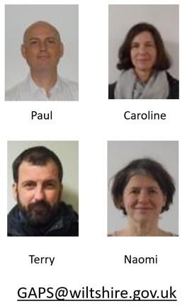

GAPS Team

Grant Application and Planting Support

* Can help you to design a tree planting project, either in one year or over several years
* Help you find appropriate funding for your project
* Including amenity trees, hedges, orchards…
* Help you to find suitable teaching resources, plan planting days, help you understand how to care for trees as they

grow

1 2

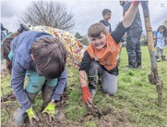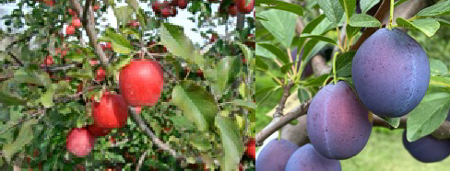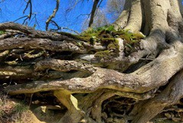

Benefits of trees

**For health:**

* Exercise and mental health benefits when caring for nature
* Reducing air pollution
* Fresh food produce

**For the environment:**

* Increasing biodiversity, creating new habitat
* Reducing flood risk by slowing the flow
* Reducing water pollution
* Storing carbon to combat climate change

**For profit:**

* Providing shade and shelter for livestock, increasing yields and

welfare

* Diversify income (timber, fruit crops, coppice…)
* Generate carbon credits
* Improve soil

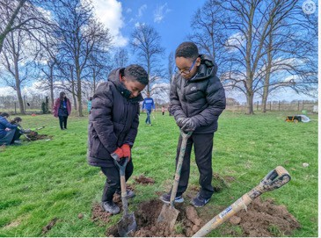

Hazards of trees

* Poisons eg yew berries
* Thorns
* Exaccerbating hay fever
* Allergens e.g. nuts
* Risks involved in tool use
* Falling branches, roots as trip hazards
* Slipping on fallen leaves
* Can trap pollution
* Costs of maintenance and dealing with disease
* Blocking light and views
* Impact on archaeology and underground services

3 4



Right tree in the right place…

…for the right purpose with the right maintenance

* How big will it get?
* What do we want the tree for?
* Which species is best for this purpose?
* What could damage it, or eat it?
* Are there any problems specific to this species?
* How can we best protect it?
* What problems could the tree cause?
* What maintenance will it need, who will do it and when?

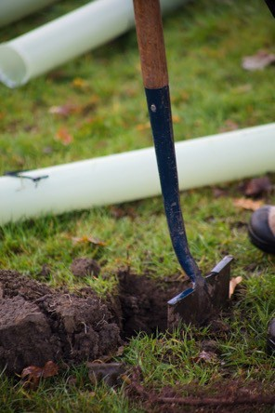

Grants available…

* Coronation Living Heritage Orchards
* Tree Council Branching Out Fund
* Woodland Trust
* EWCO
* Countryside Stewardship

5 6

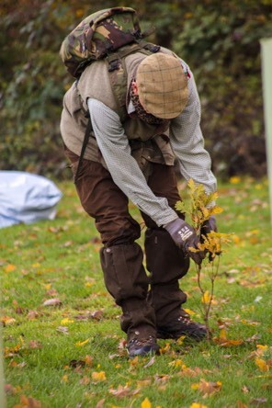

Tree Warden Scheme

We are encouraging people to volunteer as tree wardens to:

* assist their parish/town council
* survey existing trees in their area
* identify new places to plant trees and local landowners who are keen to plant
* apply for funding for tree, hedgerow and woodland planting in their community.
* Approved by the **Tree Council**
* All training provided



Things our Wiltshire tree wardens have been doing

* Organising environmental talks (Chapmanslade)
* Organising orchard wassails (Chapmanslade, Warminster, Bradford on Avon)
* Setting up a tree walk (Warminster, Salisbury)

- Identifying possible planting sites and approaching the Wilts Council GAPS team for more

information on ownership (Warminster)

- Talking to local landowners about tree planting opportunities (Steeple Langford)

- Discussing tree planting opportunities with their parish (Warminster, Steeple Ashton, many

more….)

* Attending orchard pruning events (Corsley, Warminster, Bratton)
* Applying for the Coronation Living Heritage Fund orchard grant , Branching Out or Woodland Trust grants
* Attending online training
* Find out about tree and woodland events locally
* Leading or volunteering for *Friends of…* groups (Salisbury)

7 8



Things our Wiltshire tree wardens are planning to do

* Setting up a tree nursery / visit a tree nursery
* Collecting and re-use tree guards and shelters on local landowners’ land

9